

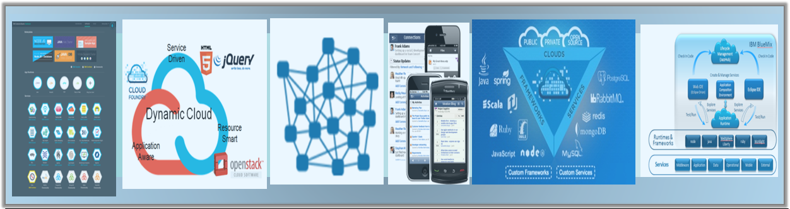

Whitepaper:

How to Build a Customer Point of View (PoV)

Table of Content

­

1. Introduction 3

1.1 Goals and Objectives 3

1.2 The Need for a Customer PoV 3

1.3 Assumptions 3

2. High Level Overview 5

2.1 Overall Approach 5

2.1.1 Understanding The Customer 6

2.1.2 Building the PoV 8

2.1.3 Conducting a Workshop with Customer 8

3. Building a Customer PoV 9

3.1 Approach 9

3.2 Capturing and Sharing Customer PoV 13

4. The PoV Output 14

4.1 Sample PoV Outline 14

Appendix A 15

Design Thinking Artifacts Summary 15

5. Document Control 16

# Introduction

## Goals and Objectives

The overall objective of the Customer Point of View (PoV) document is to provide a very compelling business-oriented recommendation for customers regarding a specific business problem. The PoV is expected to be a discussion starter and a door opener to pursue further discovery and validation activities with customers. Moreover, the PoV should be used to influence elements of a client’s strategy that are related to the area of the PoV, e.g. Retail Industry->Customer Experience. Influencing customer's opinion can be achieved through many channels. One of the most effective methods is to provide customers with an innovative vision on how some sections of their business can be transformed by the incorporation of major disrupting forces and technologies to their organizations to produce innovative and exciting user experiences that will lead to better results.

## The Need for a Customer PoV

The latest advancements in Cloud, Analytics, Mobile, Social, Security and SaaS are on the minds of every customer and how such changes would impact their business. The impact can be significant since changes to business models are already underway, new threats from competitors are becoming more common, and loyal customers are suddenly having a variety of different service offerings that are too compelling to ignore. Moreover, customer expectations are on the rise and companies have to work harder to keep their customers, and enhance their existing offerings and services to thwart competitive threats. Therefore, many clients welcome opportunities that may explore fresh innovative ideas, address their pain points, enhance their business models, and provide innovative solutions to their business imperatives.

Every organization nowadays has either created or is in the process of creating their own strategy to deal with major technology trends that are the basis for digital transformation. Some organizations are more advanced than others. Other organizations may not have the capacity or the means to understand all these major trends and their impact on their business. It is incumbent on architects, as trusted advisors for their clients, to lead with such discussions to ensure their clients are having the best strategies for such new trends and how to benefit from them. Moreover, virtually all competitors of IBM are racing to convince clients, including yours, of their own PoVs, which certainly does not include IBM offerings.

## Assumptions

1- Client Maturity

With every strategic IT and business efforts, it is very important to understand your client's maturity and the state of their business and IT before making any type of recommendations. Building a Customer PoV is no exception and you are encouraged to factor in client maturity as part of the thought process. Resulting PoVs should be thought provoking yet achievable from the client’s perspective.

2- Client Understanding

It is assumed that architects building PoVs for their clients are well versed and equipped to do so in terms of their understanding of their clients and their industry. If you need help in this area, you are encouraged to engage appropriate resources in IBM for additional support.

3- Customer PoV as a Conversation Starter

One of the primary objectives of building a Customer PoV for your client is to generate a list of topics to engage with your client. It is assumed that architects building the Customer PoV for their clients are well versed and equipped to do so. As part of the PoV, you should identify thought provoking scenarios that can be used to open up discussions about business innovation that is driven by thinking in new terms and technologies.

4- Design Thinking Practices

This document refers to key practices of IBM Design Thinking framework without defining the details behind each practice. It is assumed that practitioners who are using this document are well versed in the terminology and practice of IBM Design Thinking activities. (See Appendix A for a brief summary of key IBM Design Thinking artifacts.)

5- Incremental Approach

The steps associated with building the Customer PoV for a client is incremental in nature. Having a strategic outlook is great, but you will need to have quick wins in mind as you present your findings to customers. An incremental approach works great here and you are expected to work iteratively on this with customers to produce the final results.

6- Partial Strategy

The intention of the IBM-provided Customer PoV is not to be comprehensive. This is an objective that needs to be reached iteratively with significant involvement with the client. As part of this process, the key focus is on the most pressing items that a customer needs to address for the short term while providing significant benefits. Therefore, the initial Customer PoV may only address a selection of the business capabilities and not necessarily all of them.

7- Right Audience

The PoV focuses primarily on business-related problems. Therefore, it is crucial to have the right sponsors from within the customer’s LOBs to have good traction and opportunity to succeed. Involving IT is important as well but they are not the primary audience for the activities in this document.

# High Level Overview

## Overall Approach

The objective of creating customer specific PoVs is to expose new business opportunities or to address a major set of pain points that are impacting your customers, or a combination of both. New business opportunities are a direct result from understanding your customer needs and blending in elements of new technologies. For example, the introduction of cloud, analytics, mobile, and social capabilities in order to create a new business opportunity or user experience that is innovative and delightful. Existing pain points will also benefit from including previously mentioned mega technology trends to provide a new perspective on how to address such pain points through a new set of capabilities that were not available before.

In order to create great PoVs that will attract the attention of customers, we put elements of Design Thinking to good use. A good PoV is one that provides a compelling outcome for the customer and cannot be ignored when customers hear if for the first time. The Observe phase of the IBM Deign Thinking framework is appropriate for the top section based on applying core practices of Design Thinking. This is represented in the below diagram through the top section bubbles that feed into the PoV bubble in the middle. The Observe phase is all about understanding the customer and making sure that we have the right inputs before addressing any potential pain points or proposing a new business capability.

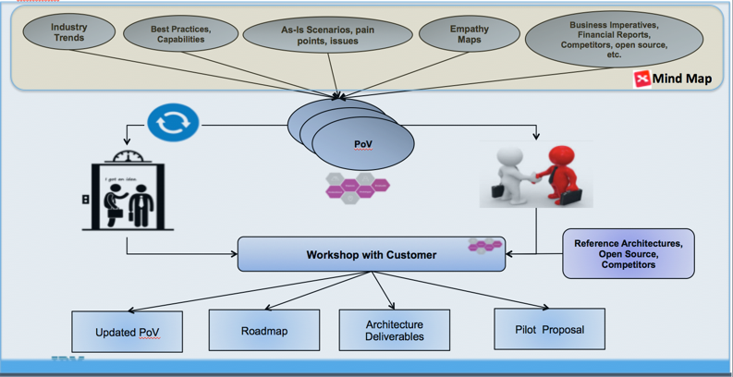

**Figure 1: *High Level Approach for Preparation, PoV and Workshop Activities***

### Understanding The Customer

The first step in developing an impactful PoV is to understand the customer. In order to understand the customer, two primary sets of information about the customer shall be collected: industry specific, and customer specific.

**Industry Specific** data is primarily concerned with the needed background information that may shed light on some of the priorities for a particular industry. It also includes a rich set of information that can vary by industry and can include some of the following items:

* **Industry Trends** provide us with a current evaluation of what may be happening in the industry. As Trusted Advisors and architects who know our customer priorities, we should be able to recognize which of the Industry Trends are applicable to our customers and how to benefit from it. Industry trends may also include generic industry PoVs that are important to understanding which aspects are applicable to your client, and can be reused.
* **Best Practices and Capabilities** are proven set of capabilities that have worked repeatedly to address a potential pattern of issues/needs that were required for a given task for a variety of customers. Realizing which best practice is applicable to your customer can save you a good amount of time rather than reinventing the wheel. It also provides a good base for innovation to start from if your customer may share partial elements of the underlying pattern. This section may also include existing reference architectures, industry reference architectures, and any additional industry blueprints that may aid in the development of a PoV.
* **Business Imperatives** of your customer are those important strategic goals and objectives that are communicated by customers at large and drive many of the overall business decisions at organizations. They are generally strong, focused objectives that will drive and strengthen a customer’s business [Wikipedia].
* **Competitors and Open Source** have matured significantly over the course of last 10 years. It is important to understand competitors at two levels. One level is the competitor of your customer. For example, if your customer is an insurance company, are they the leader of the pack or a follower. Who are their primary competitors and how are they performing in the market in comparison to your client. This level of understanding should assist you on the business side and help to realize some of the gaps that your client may be suffering from. This would provide for some additional ideas to explore. The second level is knowing which IBM competitors exist on the account that may be competing for your client’s business. What are their strengths and weaknesses and how will you position IBM as the best partner for your client. Finally, Open Source technologies are very compelling and comprehensive these days. Do not automatically dismiss it especially if your customer has a lot of respect for open source. Try to assess the strengths and weaknesses of competing open source. In some instances, an open source could be a better fit for your customer. You may position the IBM solution around an open source offering and build on top of that in future releases.
* On the other hand, **Clien**t **Specific** data is focused on information that are related to the customer that is targeted for the PoV. It includes the following elements:
  + **Current State** of the existing ecosystem at the customer. For example, including elements about the application architecture, system context, or IBM install base are all examples of items to be included. Additional relevant information for a particular industry may also be included. For example, in the case of retail stores, a common description of technology at stores would be a good piece of information to include, especially if there are existing pain points associated with existing store technology footprint or related to the business operations of the store.
  + Understanding **As-Is Scenarios, Pain Points and Issues** is one of the major tenets to creating great to-be stories and scenarios. The objective here is to be contextual and relate a set of pain points and issues to a given business process. This will make the pain points more vivid and the outcome to be more compelling since you will provide an outcome that will be directly linked to a painful as-is scenario. Every organization will have a set of basic as-is scenarios that touch on the majority of customers. The goal is to pick an as-is scenario that is fraught with issues since that provides the best opportunities to benefit the end user customers of your client, and as result benefiting your client. As part of this step, think about the potential user that may be suffering from the most pain points because of an existing as-is scenario. For example, in retail banking where there is a process to handle credit card fraud, there could be two primary users interacting. One user is the agent from the bank and the second user is your client’s customer who just saw his credit card statement and is calling about a potential fraud.
  + **Empathy Maps** provide a methodical procedure on how to document the needs of your users (**Personas**), once they are identified
  + **Financial Reports** can be used to decipher elements of information that can be useful for your PoV. For example, if you can identify a huge cost that can be attributed to an existing inefficient as-is business scenario that would provide a great starting place.

To help organize the need “*Discovery*” data (both the industry specific and client specific data), a template structure has benn packaged in a MindMap. A **MindMap** is a diagram used to visually organize information. A MindMap is hierarchical and shows relationships among pieces of the whole. It is often created around a single concept, e.g. Persona, that is a key in exposing customer issues, and provides us with the ammunition to create potential compelling business outcomes. The goal is to provide a repository of these “Discovery” MindMaps, created and maintained by the field, and available for various industries that provide (links to) explicit industry and market segment insight. The number of Personas that you identify for your customer will govern the number of MindMaps you will want to create. It is expected that each Persona will require its own MindMap. The Discovery MindMap repository is available in the TeamSD ([Method Supplemental Assets – Discovery Mindmaps](http://ibm.biz/DiscoveryMindMaps)) Wiki in the TeamSD Next Cloud Connections community.

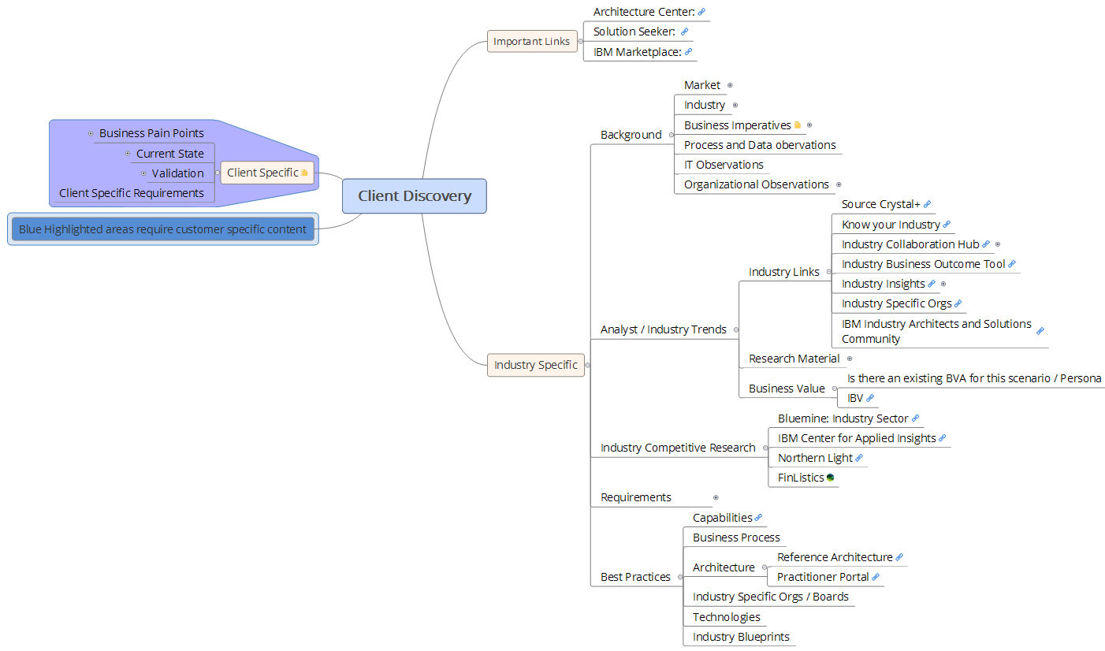

**Figure 2: *Sample Discovery MindMap***

### Building the PoV

Once all the required input is captured and ready for you, you should engage in the Reflect phase of the Design Thinking approach. Reflect is all about ideation and coming up with innovative solutions and scenarios to address many of the pain points that were uncovered in the Observe phase. The objective here is not to address all the pain points that may have been uncovered, but to prioritize on a set of pain points that would provide a significant value if they were to be turned into delightful experiences.

The collection of delightful experiences should translate into a well-organized story that is very compelling to our clients. In addition, the story should be able to convey value without having to do major elaboration and provide a short snippet that we refer to as the Elevator Pitch. The Elevator Pitch summarizes the compelling value in less than two minutes and customers should relate to it immediately. Once the Elevator Pitch is ready, architects should communicate it to their clients and watch for positive feedback. If no positive feedback was provided, architects must go back to the drawing board to come up with a more compelling business scenario. On the other hand, if the feedback from the Elevator Pitch is very positive, that should open the door to further discussion and exploration with the client. Further details about this step are included in section 3 of this document.

### Conducting a Workshop with Customer

Ideally, an optional workshop can be proposed and executed to validate the discovery process of the PoV. In the Workshop with Customer phase, we work with our customers to address the impact of adopting disruptive technologies and trends on their business, and realize the vision stipulated in the PoV. In general, there are two modes of operation: Discovery mode and Solution Architecture mode. The Discovery component of the workshop allows customers to brainstorm/validate new fresh ideas and scenarios that may have significant and compelling business value. On the other hand, the Solution Architecture component will guide customers, in collaboration with IBM architects, through the activities to architect the vision discovered earlier while taking into consideration the existing client's IT ecosystem.

The workshop will follow a consultative approach through the use of customer PoVs, real case studies, and industry trends and best practices. Moreover, the workshop will guide organizations on their new path to value by assisting them with determining the biggest and highest value opportunities that can be meaningfully realized given an organization's maturity and readiness. As a result, a collaborative and executable plan for moving forward will be created to maximize the delivery benefits and reduce the risk of implementation of newly discovered and innovative business capabilities. The workshop will also incorporate elements of IBM Design Thinking and Agile development practices to address user experience questions, and implementation best practices. For details about this step see Guideline: **Digital Transformation Workshop**.

# Building a Customer PoV

## Approach

The overall approach for building a Customer PoV centers on offering compelling business value to customers and competitive differentiators as a result of digital transformation endeavors. The architect as a trusted advisor for customers in the top accounts category should be well equipped to provide such a view based on their knowledge of the account, relationships, and familiarity of the industry and competitors of their customers.

The following diagram outlines the approach for building the client's PoV with details for each step to follow.

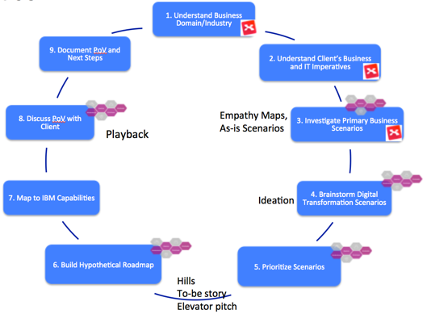

**Figure 3*: Building a Customer PoV Approach***

**1- Understand Business Domain/Industry**

As a trusted advisor, architects are expected to have some knowledge of the industry and the business domain where their clients are operating. As part of that process, architects review industry's latest news and trends and develop their own understanding of a particular industry. Furthermore, architects should develop their own perspective on what practices of the industry could benefits their customers and which trends are important to discuss with customers. As outlined earlier, this information should be part of the MindMap that is associated with the customer’s industry, if such a MindMap has been created.

**Assets to leverage**: Existing customer MindMaps that may include pointers to customer background information, analyst/industry trends, client specific information, industry competitive research, generic industry PoVs, and best practices.

**For a collection of existing MindMaps, or posting new MindMap, refer to this** [link](http://ibm.biz/DiscoveryMindMaps) **(http://ibm.biz/DiscoveryMindMaps)**

**2- Understand Client's Business and IT Imperatives**

Understanding a client’s business and IT imperatives is key to developing a compelling PoV for customers. As industry information is processed from previous step, injecting the knowledge about the client’s top business and IT imperatives would provide enhanced knowledge to come up with fresh and innovative ideas in the later steps of the process. It is important to empathize with existing pain points to have a better perspective on what may be causing such pain points and how to address them afterwards. Pain points could be either related to business processes due to inefficient business processes, or in other instances tightly coupled with antiquated use of technology. Architects at top accounts are typically in a position to provide some answers to address customer pain points through technology and business solutions. As outlined earlier, this information should be part of the MindMap that is associated with the customer’s industry, if such a MindMap has been created.

**Assets to leverage**: Existing customer MindMaps that may include pointers to customer background information, analyst/industry trends, client specific information, industry competitive research, and best practices.

**For a collection of existing MindMaps, or posting new MindMap, refer to this** [link](http://ibm.biz/DiscoveryMindMaps) **(http://ibm.biz/DiscoveryMindMaps)**

**3- Investigate Primary Business Processes**

Every organization has a set of primary processes that touch customers and where the majority of customers are impacted by such processes in one way or another. For example, a banking organization's Account Open is one of the primary processes at almost every bank. Having an efficient Account Open process with the right user experience would go a long way in providing differentiated service for a customer. As part of building a customer PoV for clients, primary processes are top candidates for investigation to ensure that there are no business issues associated with them. Furthermore, envisioning a better business process that engages customers in a different manner and provide superior services would be a door opener for discussions with clients.

This step relies heavily in applying techniques from IBM Design Thinking framework to document Empathy Maps and As-Is scenarios for some of the primary personas that you feel are important to consider. In general, addressing the lower level consumer-type personas would yield significant information since customer-facing processes are almost always ripe for enhancement and would provide a significant impact in terms of benefits. Investigating two personas with two different as-is processes would yield a better perspective and better opportunities for further innovation in the later steps of the PoV process. As outlined earlier, this information should be part of the MindMap that is associated with the customer’s industry, if such a MindMap has been created.

**Assets to leverage**: Existing customer MindMaps that may include pointers to customer background, which includes business imperatives, process and data observations, IT observations, and organizational observations.

**For a collection of existing MindMaps, or posting new MindMap, refer to this** [link](http://ibm.biz/DiscoveryMindMaps) **(http://ibm.biz/DiscoveryMindMaps)**

**Output: Identification of Primary Personas, Empathy Maps, Documentation of a Problematic As-Is scenario**

**4- Brainstorm Digital Transformation Scenarios**

Clients look for technology to provide them with competitive advantages and business differentiators. Once a client's primary business processes are investigated, and business and IT imperatives are documented, it should become easier to start brainstorming for some potential scenarios that may challenge the current status quo with customers in an effort to come up with new or enhanced scenarios that leverage new technology trends. The objective of this step is to brainstorm with the account team and industry experts on some innovation at the business level to open the door for discussion with customers. Depending on your understanding of the client and your knowledge of the industry, you should strive to work through three to five business scenarios that may get impacted based on the incorporation of new technologies to be more innovative.

As part of this process, you may have access to existing PoVs that may be available through the associated MindMap for your customer. The provided PoVs should be used to learn what is useful and trending for the industry, or a given portion of the business of your customer in a generic sense. However, your objective as part of this step is to customize such PoVs and bring them closer to your specific client’s needs based on the wealth of information that you have gone through in the previous steps.

Each identified scenario should have a value statement, or an elevator pitch, that can be communicated in less than two minutes, which conveys clear and compelling business value, and does not require a lot of elaboration. The value statements will be used to validate our thinking with clients in the later steps of the process.

**Assets to leverage**: Existing customer MindMaps that may include pointers to requirements, PoV Elements, and any other information that may have been used in the earlier steps. Also any existing PoVs that address similar customers, similar personas and similar pain points.

**For a collection of existing MindMaps, or posting new MindMap, refer to (**<http://ibm.biz/DiscoveryMindMaps>**); For a collection of field authored PoVs that follow the companion PoV Template format, refer to (**<http://ibm.biz/ClientPoVs>**)**

**Output: A set of scenarios along with a summarized version of their value statements (elevator pitch)**

**5- Prioritize Scenarios**

Once scenarios are identified, use your knowledge of the client pain points, business imperatives, gaps, priorities to classify documented scenarios based on business impact and ease of implementation. Your can leverage the Design Thinking approach of prioritization which ranks idea clusters based on importance and feasibility. The combination of higher business value and easier implementation will make a scenario a top priority for discussion with clients.

The combination of scenarios including their collective value statements would provide for a significant wow factor that should be very compelling for customers. This is what we usually refer to as Hills in Design Thinking terminology. It allows us to align scope and provide a crisp statement to what will be delivered in terms of who, what and wow. Once you have the Hill statement created, you should be thinking about your to-be story that may combine a set of scenarios together to provide an exciting user experience or to turn a pain point into a delight.

Once you reach this step, you should practice the value statements and approach the customer to get their initial feedback. If customers react very favorably and are interested in pursuing the idea for further elaboration, this is a good indicator that we are on the right path. On the other hand, if the customer’s reactions were not favorable, further brainstorming would be required to generate the right innovative ideas along with their associated value statements. It is expected that such process would be repeated until the client agrees to the value statement and feels excited about having more discussions.

**Assets to leverage**: Set of scenarios that were developed in previous steps along with any MindMap information that was reviewed in the previous steps that may help you in the prioritization process to determine the importance or business impact.

**Output: A set of prioritized scenarios along with a summarized version of their value statements (elevator pitch)**

**Hill Statement**

**Storyboard that may combine multiple scenarios to provide a significant wow factor**

**6- Build a Hypothetical Roadmap**

Given the identified top three scenarios, your hill statement, and the storyboard you created, combined with your knowledge of the customer's ecosystem, build a high level hypothetical roadmap to generate and solicit customer feedback. The roadmap should take customer’s maturity into perspective and provide a consumable route for potential implementation. This deliverable is very high level but should be grounded in reality and takes into consideration any organizational factors at the client that may either expedite or impede the implementation. For example, skills and resources are key considerations to incorporate as you build your roadmap waves. Having a hypothetical, yet realistic, roadmap available would show your customer that you have thought about the proposal seriously and have taken extra care to take the existing ecosystem into consideration as part of the roadmap creation process.

**Assets to leverage**: Prioritized scenarios, Hill statement, storyboard, and MindMap info about the existing IT footprint.

**Output: Roadmap**

**7- Map to IBM Capabilities**

This step will give you the opportunity to be prepared to answer questions about which IBM solutions would be required to realize the PoV that you brainstormed earlier. The primary objective of this step is to assess the architectural situation at the client and given the storyboard that you created, what would be the right architectural decisions to make. Clearly, as you consider IBM set of solutions or products, you should keep in mind any existing IT footprint and competitor’s situation before making any decisions. Moreover, if certain IBM products do not meet customer demands, be prepared to admit that and offer the right solutions even if that means recommending an open source tool to fill a gap. Ideally, all IBM products should be considered first especially if they are a good match. However, this may not be necessarily the case all the time with all customers.

**Assets to leverage**: Prioritized scenarios, Hill statement, storyboard, MindMap information about competitor’s, Best practices, and reference architectures.

**Output: Architectural decisions, list of potential IBM solutions or competitor’s/open source products**

**8- Discuss PoV with Client**

During this step, you may have discussed the value statements with the client and the client is very interested in hearing more. On the other hand, the customer may invite your directly to do an exercise where a PoV can be created collaboratively with client personnel.

In this case, you have to master all the customer background information that was included as part of the MindMap and be prepared to discuss industry trends and best practices. Moreover, if you are coming prepared with your own storyboard, you will need to do a validation step with the client to make sure that you both have the same understanding of what is being offered.

During this playback step, it is a normal practice for clients to show some resistance for bold ideas that may have deep business impacts. Be prepared to articulate your value statement and understand any issues that your customer is raising. Be prepared to adjust dynamically to reach a common ground.

The audience for this meeting and the agenda should be agreed upon earlier to include the right people from the business and IT side.

**9- Document PoV and Next Steps**

Once a high-level agreement is reached with the client, you can document a preliminary customer PoV using a template (see companion **Template: Client PoV**) and provide to the customer. The expectation, post the delivery of the high level PoV, is to engage with the customer in an optional deeper dive workshop to detail the PoV and translate that into an actionable roadmap. The logical next step of the Discovery and Solution Architecture workshop would provide clients with additional scenarios and details about transformative actions for their business processes. It also allows the engagement to go to the architectural level to build a solution architecture that will be friendly to the client's environment.

As outlined earlier in the document, the workshop approach may not necessarily address the solution aspects. Instead, customers may choose to continue focusing on the Discovery process and to further brainstorm additional innovative ideas to transform their business. This is a perfectly fine outcome as long as once this work is completed a set of follow-on activities are identified to realize the vision of the innovative ideas that have been discovered collaboratively with the customer.

## Capturing and Sharing Customer PoV

The next section points to a standard template for capturing the critical elements of a Customer PoV for sharing both with the customer and with your peers. There is significant value to the Technical Solution Architect community if there is consistent internal sharing of these documents. A [supplemental method asset repository](http://ibm.biz/ClientPoVs) dedicated to Customer/Client PoVs should be referenced for reusable content. The quality and variety of reusable content will be dependent on this community freely contributing their good work.

# The PoV Output

## Sample PoV Outline

Executing the previous steps of the technique paper should provide the author with elements that can be used to fill out the PoV template. The following diagram shows the sections of a sample customer PoV. It is expected that a PoV document can stand on its own when delivered to customers in PDF format. Therefore, some customer/industry background information may be repeated in the PoV document to provide the rationales for reaching out certain conclusions. (See **Template: Client PoV**)

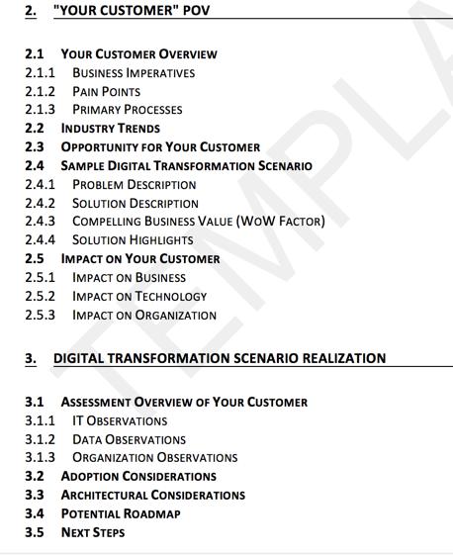

**Figure 4: *Sample PoV Sections***

# Appendix A

## Design Thinking Artifacts Summary

Throughout this documents, many of the artifacts of IBM Design Thinking were referenced. It is assumed that the consumer of this document is well versed in the practices of IBM Design Thinking. Here is a quick definition of the artifacts of IBM Design Thinking.

**Empathy Map:** An empathy map is a quick way of capturing user insights and observations. It allows us to gain empathy to develop actionable insights to create a better product and give your users a delightful experience.

**Persona:** A pattern that emerges about a user or collection of similar users once users are understood and empathy maps are developed.

**As-Is Scenario Map:** A description of the existing As-Is process as it relates to the users to further pain points and gain additional insights.

**Ideation:** A process to generate big ideas that can address the pain points that were uncovered in the As-Is Scenario Map. The ideas will be clustered and prioritized.

**Need Statement:** A statement that captures the need of a given user of the system with a clear indication to the business value that is associated with that need.

**Hills:** A statement that frames your releases around user-centric market outcomes, not feature requests.

**Playback:** Align your team, stakeholders, and clients around the user value you will deliver, rather than project line items

**Storyboard**: A to-be story that describes the new user experience that has a beginning, middle and an end.

**Prototype**: Ameans of exploring a user experience through low-fidelity representation of a design and provides a quick and effective communication tool.

# Document Control

|  |  |  |  |
| --- | --- | --- | --- |
| **Version** | **Date** | **Author** | **Comments** |
| **1.0** | **Dec 2016** | Dr. Mamoun Hirzalla ( mamoun.hirzalla@us.ibm.com ) | **Initial Version** |